DOCUMENT:

NAME:Andal priyadarshni.S
BATCH NO:TN_DA_FNB03
CONTACT NO:9176780601
E-MAIL ID:andalpriyadarshni@gmail.com
PROJECT DOMAIN:Student Details,Academic Score,Behaviour
PROJECT TITLE:Data Cleaning and visualization using Excel and Powerbi in a Student Details.
SUBMISSION:22-08-2025
MENTOR:Kumaran
DATASET LINKS: https://drive.google.com/drive/folders/1yUolgM5An8TljeoubRygeFJCgocaZrAZ?usp=STUDENT_DETAILS_link

DATA CLEANING
1.Missing State has been Replaced as UNKNOWN.
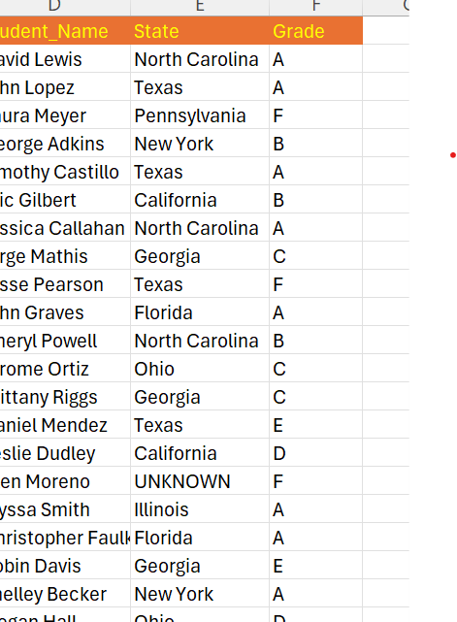

2.Performance Column has been included based on GRADE.
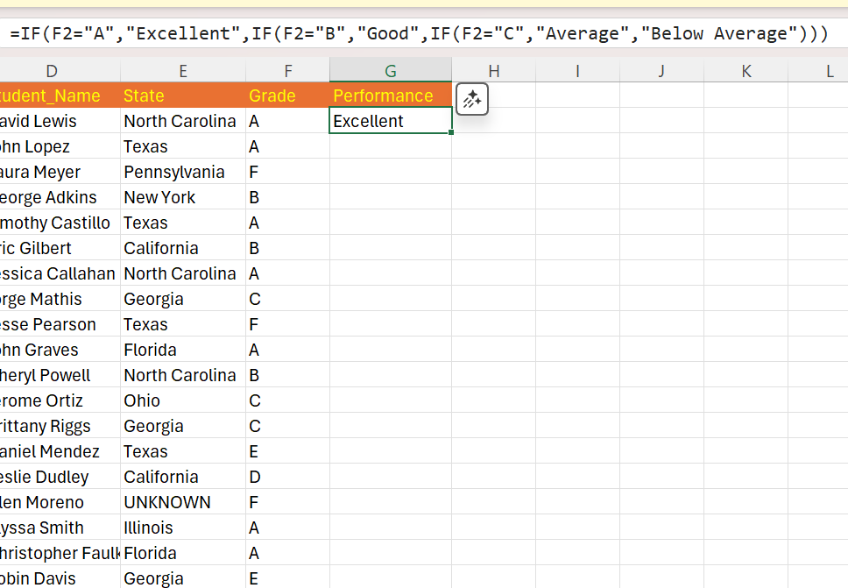
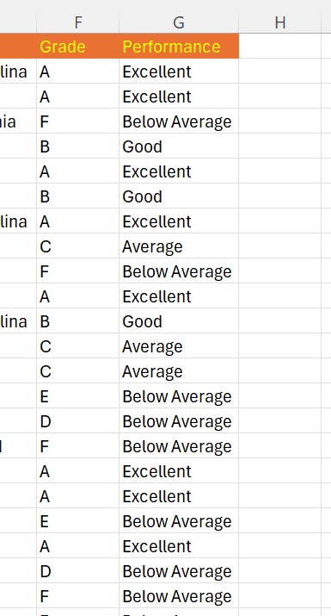

3.MISSING Values in age. Find average and replaced using Find and Replace.
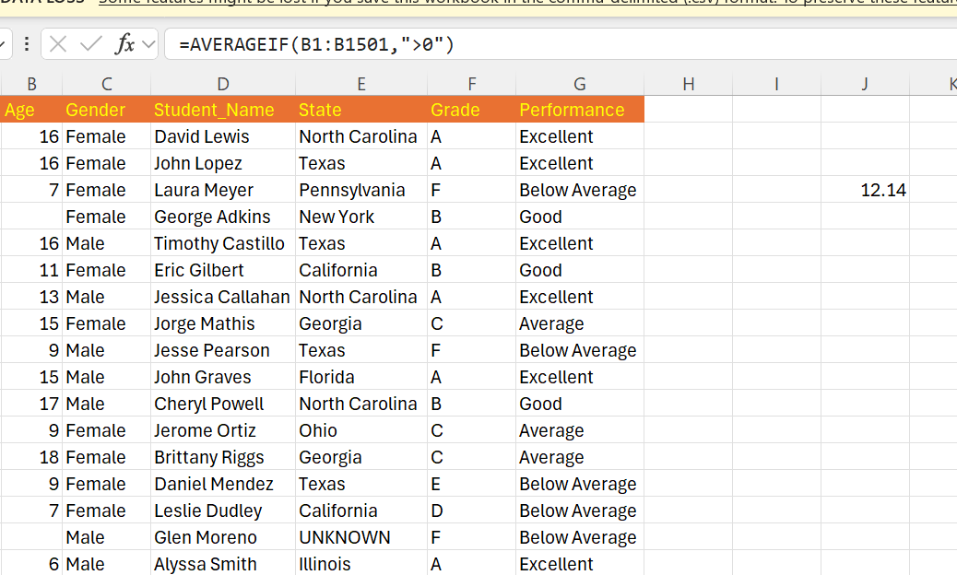
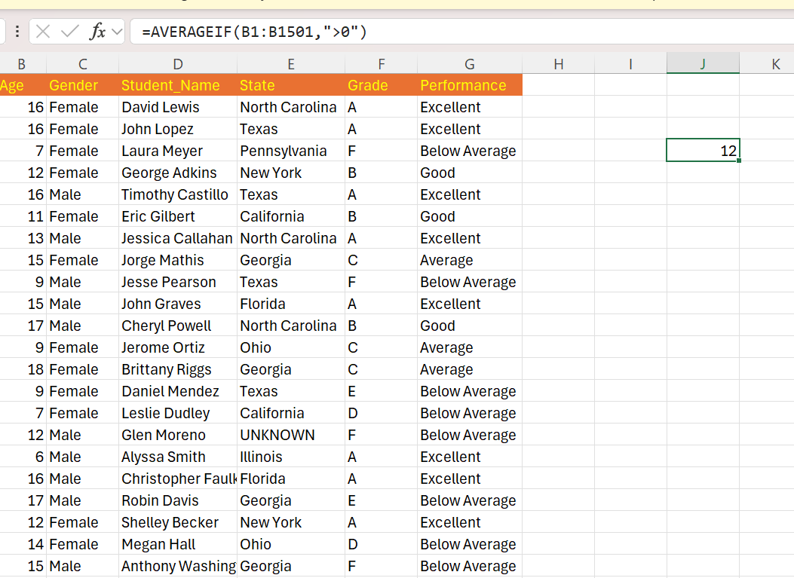

4.Position has been Calculated based on Age.
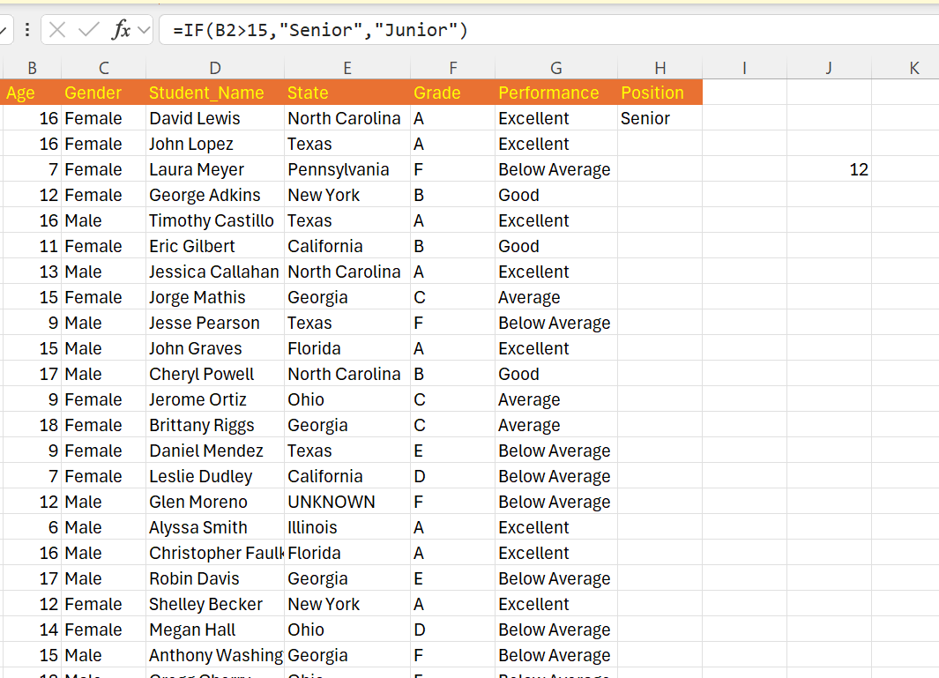
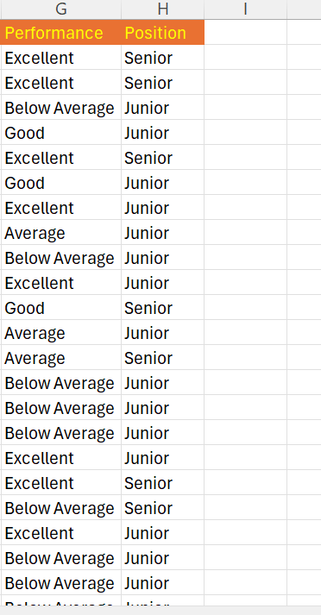

5.Total Score has been calculated.
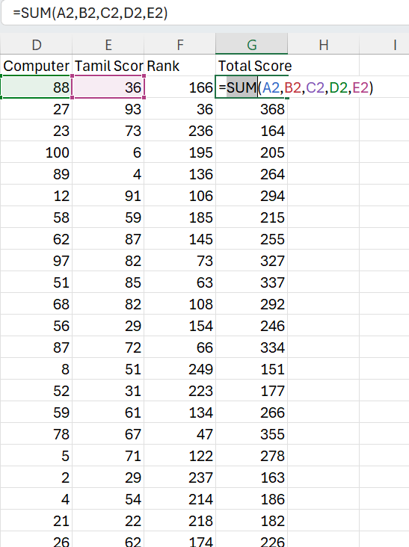

6.Punctuality Level has been calculated based on Punctuality Score.
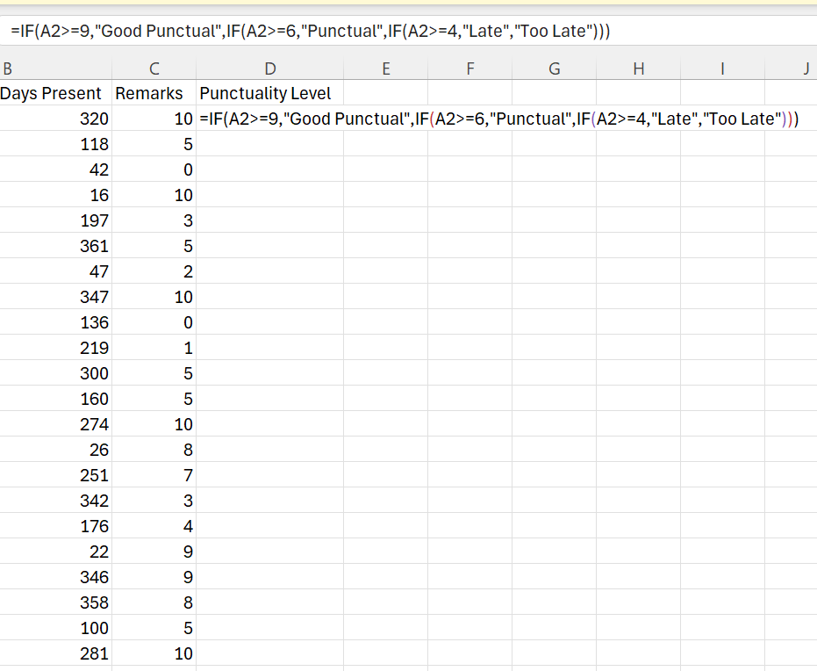
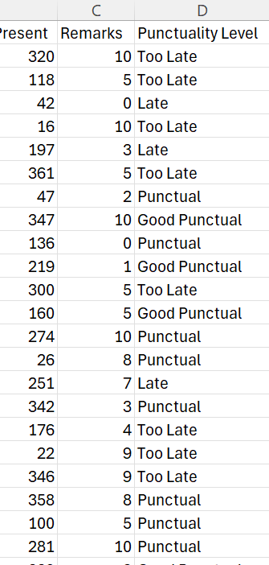

7.No.of Days Absent has been calculated by No. Of Days Present.
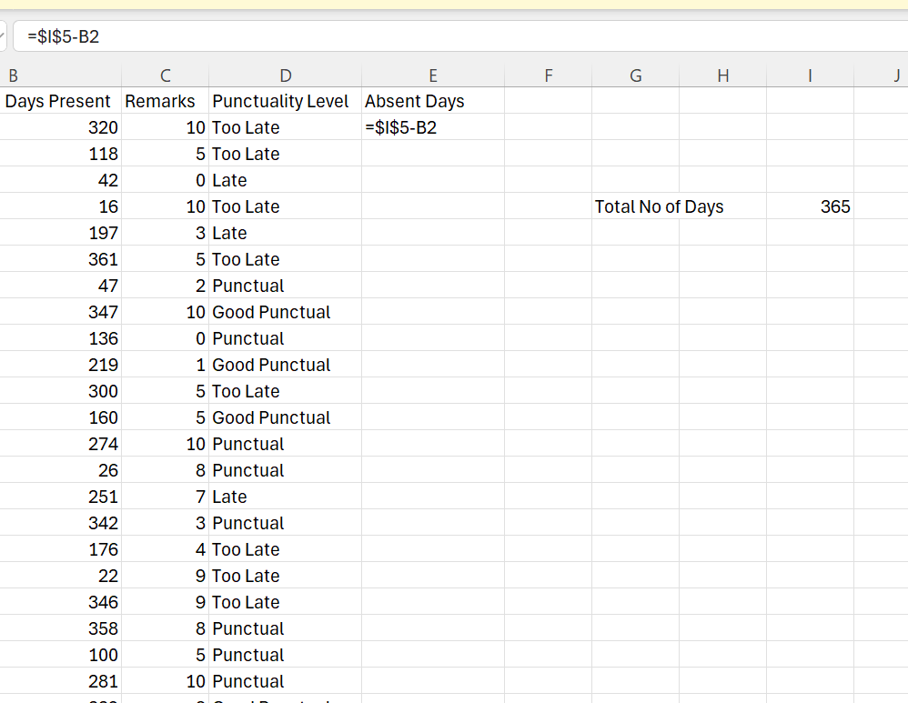
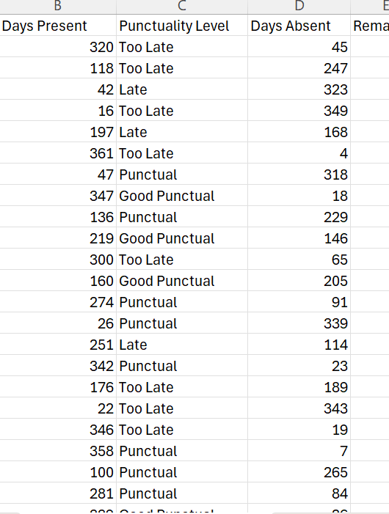

8.Date of Birth has been Calculated based on Age ( Assume Birth date is on today date in past ).Today Date :13-08-2025.
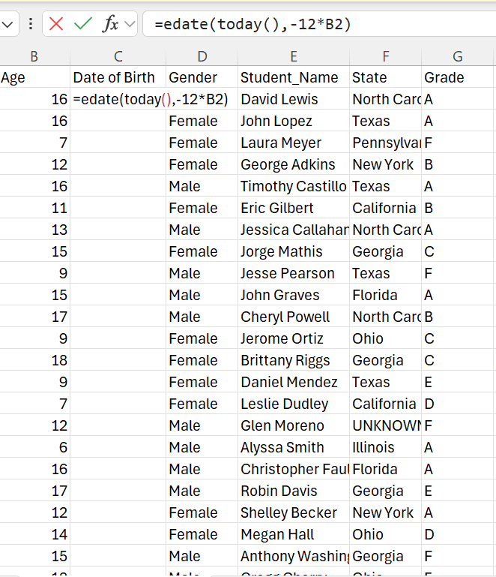
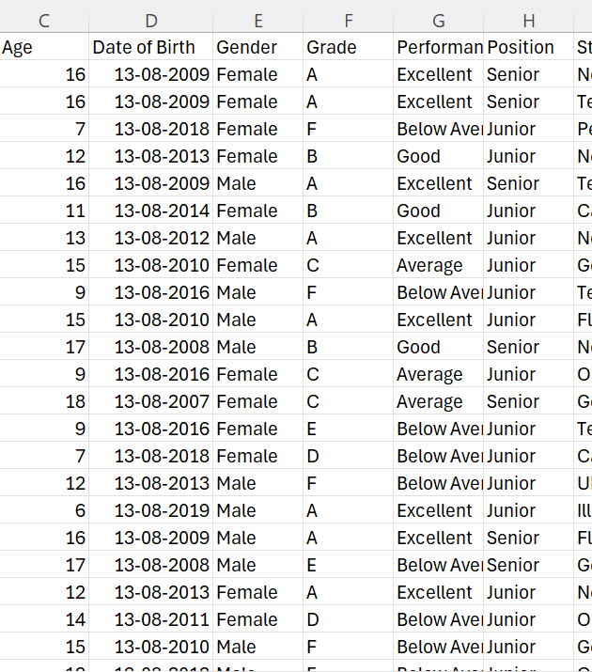

9.Result has been Calculated based on Total Marks.
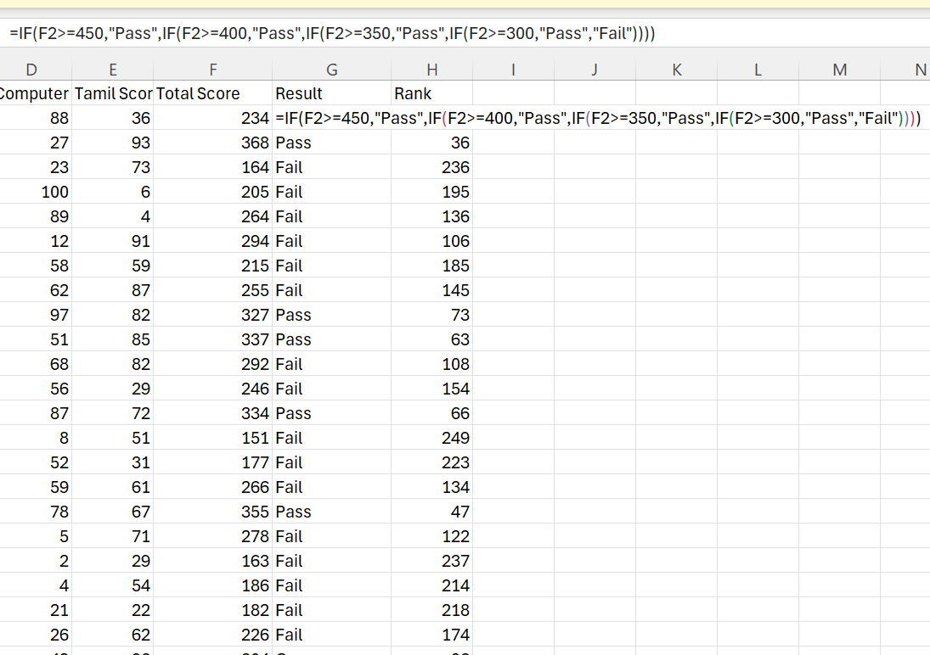
10.No Duplicates in 3 Dataset and columns has been rearranged in each dataset.

DATA VISUALIZATION
Attendence,Punctuality and Remarks.
1.The Proportion of Total Present and Absent Days Across all Students.
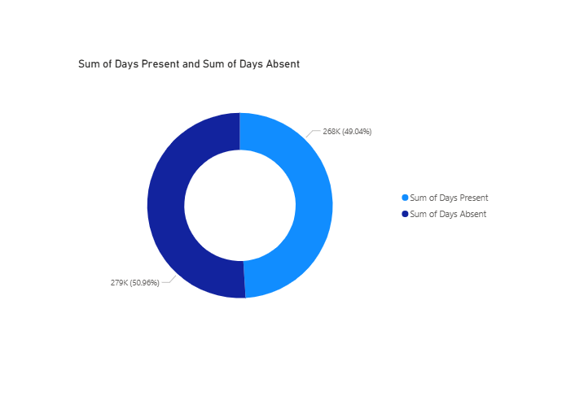

2.Punctuality Level Distribution in Each Category.
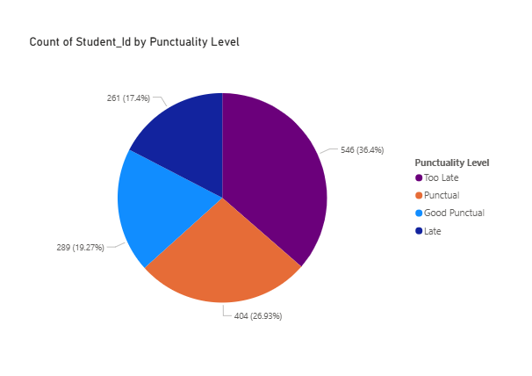
3.Punctuality Level Across State.
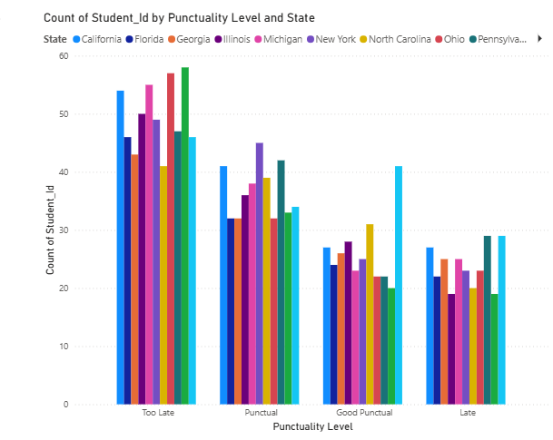

TRENDS
1.Shows how Remarks are Distributed as rank Changes.
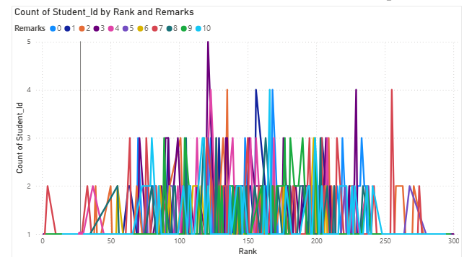
2.Quickly Identifies Top Achievers.
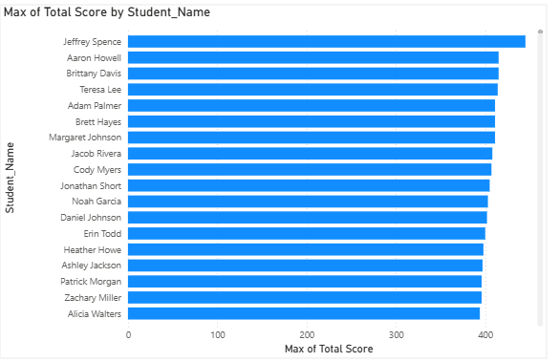

Academic Performance
1.How Result and Rank Vary by State.
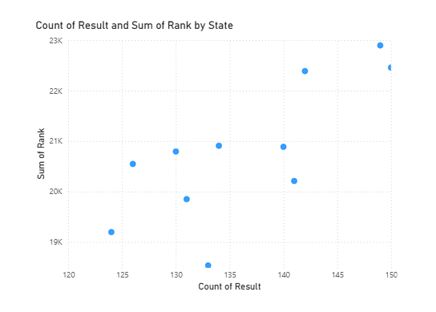
2.Shows Success Rate at a Glance.
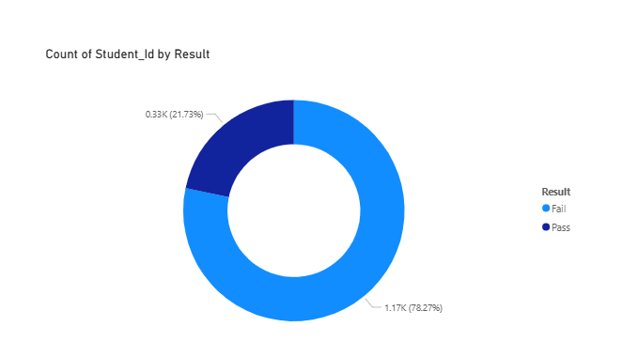

3.Sum of Total Score by State and Student ID.
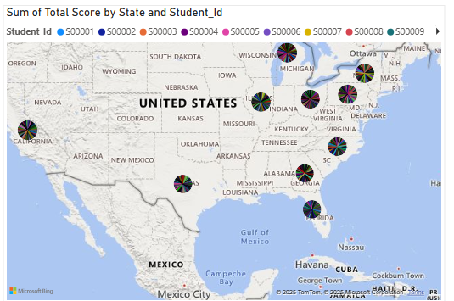
4.Quick Breakdown of Performance Category.
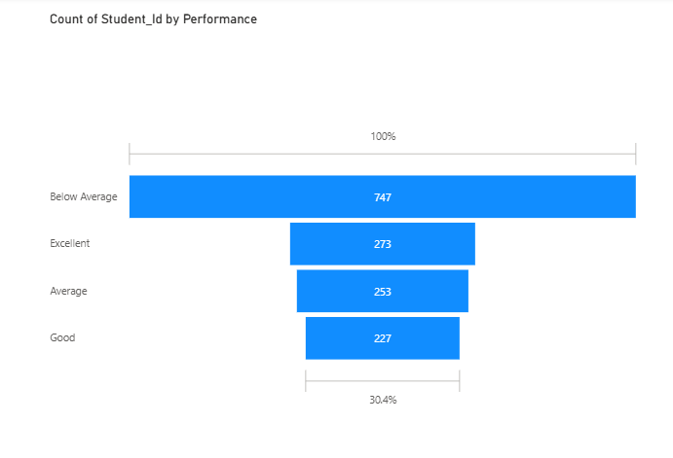

5.Min of Days Present and Min of Days Absent by Total Score.
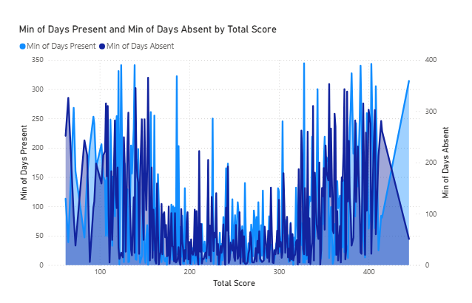
6.Count of State by Performance.
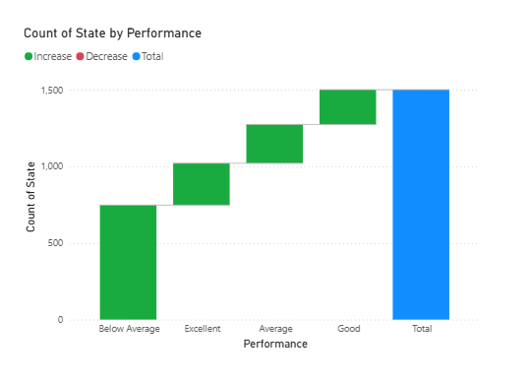

7.Count of Student ID by Grade and Gender.
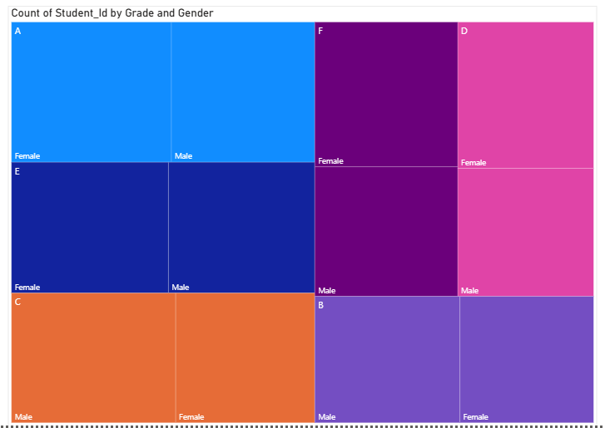
8.Average of Remarks using KPI Guage.
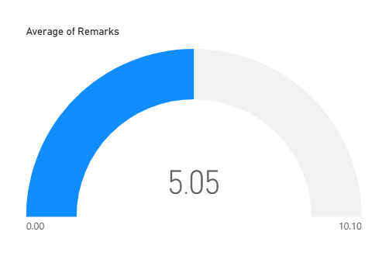

9.Maxi of Days Absent using KPI Guage.
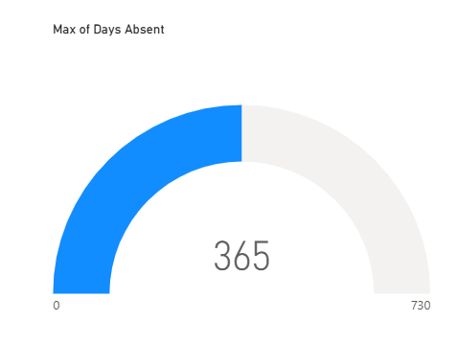
10.Two Slicers has been Added.
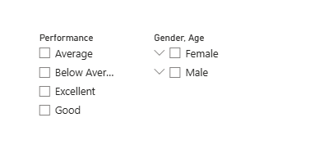

11.Total No of Students has been Calculated using Measures.
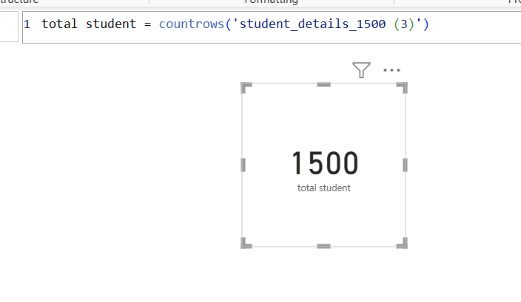
12.Average Attendence has been Calculated using Measures.
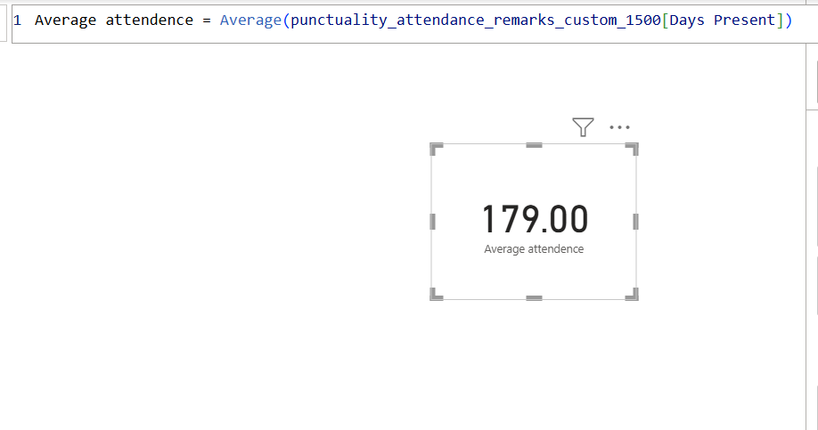

13.Maxi Score has been Calculated using Measures.
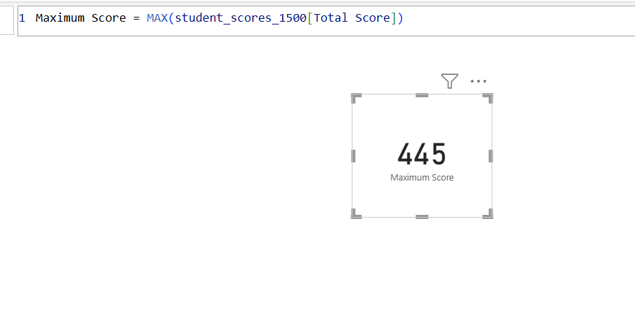

Interactive Dashboard of Student Details,Academic Performance and Behaviour.
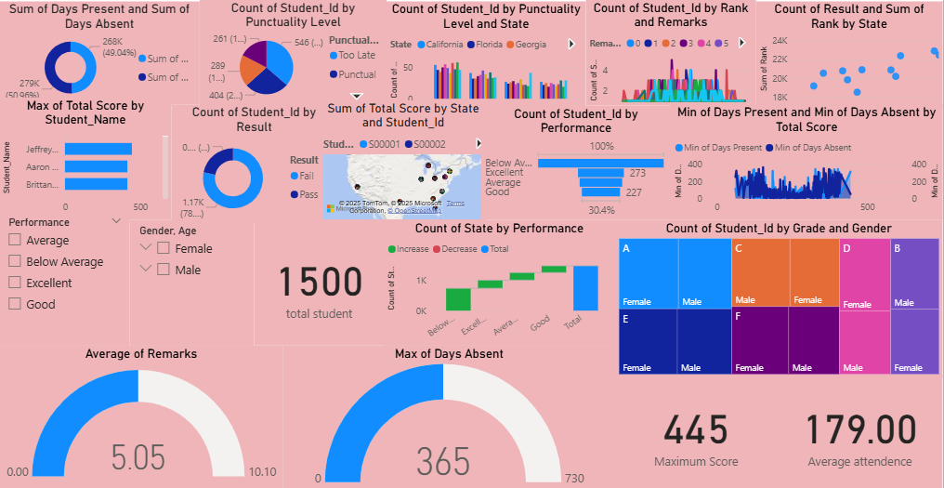
CONCLUSION:
I Have Taken a Student Dataset.Data Cleaning was Performed in Excel,followed by Data Visualization in Power BI,Where Interactive Dashboards were Created.The Dataset Highlights Students Academic and Behavioral Performance by Combining Scores,Attendence,Punctuality.It Helps Identify how Discipline and Attendence Affect Results and Ranks,Enabling Better Insights for Student Evaluation.

